Drop Rows in Pandas df:

<https://thispointer.com/python-pandas-how-to-drop-rows-in-dataframe-by-index-labels/>

Delete Rows in Pandas df based on conditions in a column:

<https://thispointer.com/python-pandas-how-to-drop-rows-in-dataframe-by-conditions-on-column-values/>

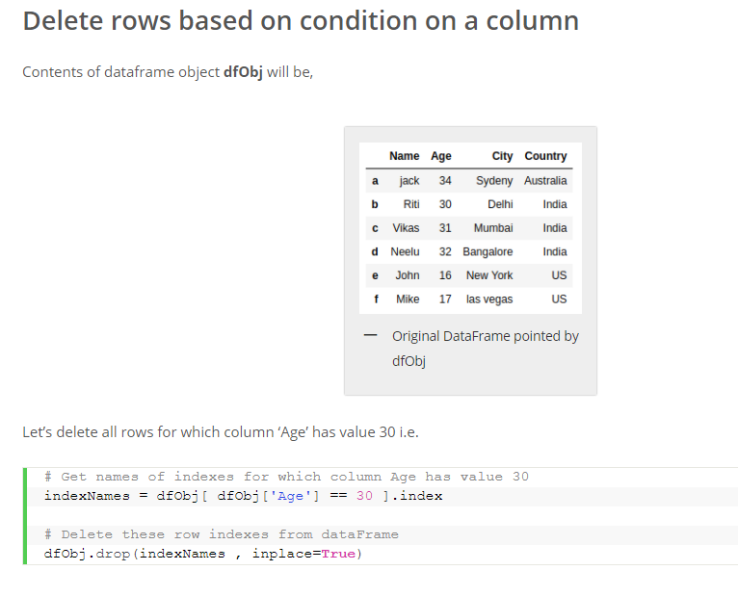

Concatenate columns in Pandas df:

<https://stackoverflow.com/questions/60201936/concatenate-column-values-in-pandas-dataframe-replacing-nan-values-with-comma>

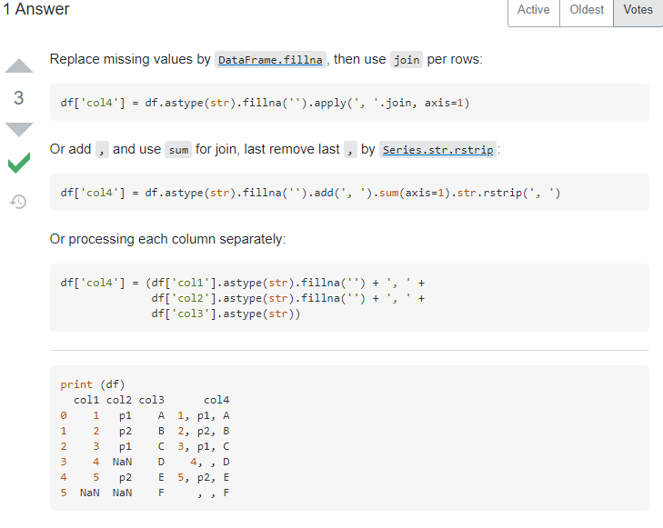

Find Duplicate Rows based on selected Column(s) in Pandas:

<https://thispointer.com/pandas-find-duplicate-rows-in-a-dataframe-based-on-all-or-selected-columns-using-dataframe-duplicated-in-python/>

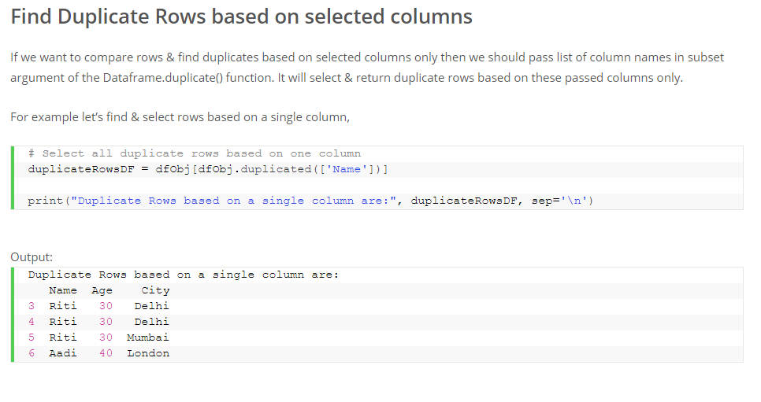

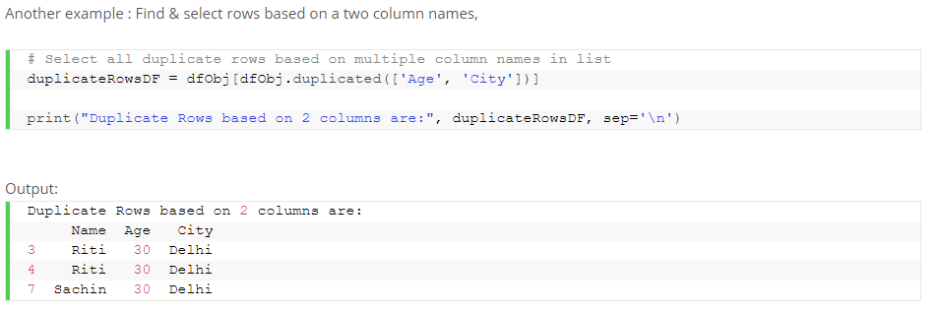

Calculating Python’s pvariance() and variance():

<https://stackabuse.com/calculating-variance-and-standard-deviation-in-python/>

